

School Nursing Newsletter
Winter 2025

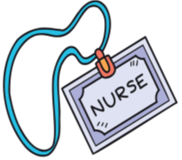

Hello and welcome to our first School Nursing Newsletter!

We will be sending this out each term to help keep you up to date with useful health tips, advice, and information to support your child’s health and wellbeing throughout their school years.

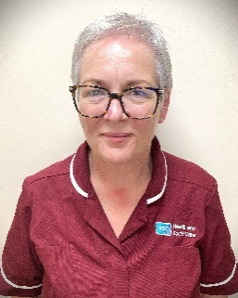

As we settle into the new school term, we would like to remind you about the vital role of the NHSCT School Nursing Team along with some important health updates relevant for this time of year.

The School Nursing Team is made up of Specialist Community Public Health Nurses (SCPHN) School Nurses, School Immunisation Team, Public Health Staff Nurses & Child Health Assistants.

We play a key role in supporting the health, wellbeing, and development of children and young people in our schools & Community.
What we do:
- Carry out health reviews and provide health advice to pupils
- Deliver health promotion sessions tailored to pupils needs
- Coordinate immunisation programmes in schools
- Support children with long term health needs
- Continence Clinics
- Work closely with families, teachers, and other professionals to ensure every child’s health needs are met.

If you have concerns about your child’s health or wellbeing, please do not hesitate to get in touch with us.

School Nursing Service - Northern Health and Social Care Trust


Introduction:
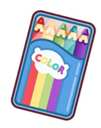









1


Health promotion for Autumn & Winter:
“As the colder months approach, it’s vital to stay vigilant about common illnesses and ensure children and young people are protected against vaccine-preventable diseases.”

Flu can spread quickly in school settings and can cause serious illness, especially in young children and those with certain medical conditions.
The NHSCT School Nurse Teams coordinates annual flu vaccinations clinics in schools, offering the nasal spray vaccine to children aged 4-17 years. This vaccine helps protect your child and those around them from the flu virus. We started our School based vaccination programme in October. If you haven’t already returned your child’s consent form to school please do so as there is still time. Even if you do not wish your child to receive the vaccination, we still need the form to be returned please.

Protecting your child against flu: Vaccination for your school child (English and translations) | HSC Public Health Agency

Flu Vaccinations:











During Years 11 & 12, the School Immunisation Team offer important vaccines to protect young people, and those around them, against serious diseases.
The ‘School Leaving Booster’ is a single injection that protects against Tetanus, Diphtheria and Polio.
This is offered alongside a single MenACWY injection. This vaccine protects against some of the most common meningococcal bacteria which can cause meningitis and septicaemia.
An additional vaccine, which protects against Measles, Mumps and Rubella, will also be offer to anyone who has not previously completed their 2-dose schedule.
Consent forms are sent home through school in early September and should be returned as soon as possible.

For further information please see:

https://vimeo.com/903636019/54a9811812

SLB Vaccinations:






2
Other Health Tips for this Season

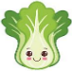



Hand hygiene:

Encourage children and young people to wash hands regularly, especially before eating and after coughing or sneezing. Teach children to cover coughs and sneezes with a tissue or their elbow to help prevent germs spreading.

Healthy eating:

Support balanced diet rich in fruits and vegetables to boost the immune system.

Eating and drinking well | Choose to Live Better


Physical Activity:

Promote daily exercise to maintain good physical and mental health.
Getting active | Choose to Live Better




“Emotional health and wellbeing are just as important as physical health. The transition to new school years, shorter daylight hours, and colder weather can affect mood and wellbeing.

Here are some tips to support your child’s emotional health during this season”.






Talk:

create a safe space for your child to share feelings and listen without judgement.

Routine:

Maintain a routine as this can give young people a sense of security & control.



Remember:

Looking after emotional health and wellbeing is a community effort - schools’ families and health professionals working together make a difference

Prioritise sleep:

ensure children and young people have a consistent bedtime routine for adequate rest, limit screen time, use relaxation techniques




Stress Awareness week 4th-8th of November 2025
Life can feel busy and stressful for adults and children. Stress Awareness week is a good reminder to slow down, talk about how we are feeling, and find healthy ways to manage pressure. Taking time for rest, fun, and connection can make a big difference to family wellbeing.
Finds tips and support Stress Awareness Week

Anti bullying week 17th -21st November 2025
This year’s theme encourages kindness and respect for everyone. Talking with your child about friendships, empathy, and standing up for others helps build confidence and creates happier school community where everyone feels they belong. Find resources and support Anti Bullying Week

Road Safety Week 17th -23rd Nov 2025
Road Safety Week reminds us all to take care on the roads, especially around schools. Whether walking, cycling, or driving, small actions- like using crossings, wearing bright clothing, and slowing down-help keep everyone safe. Find resources and information Road Safety Week

Events



3

As children spend more time online for learning, socialising and entertainment, it’s important that we support them to stay safe and make good choices. Whether they’re using apps, playing games or browsing the web, having regular conversations about online safety can make a big difference. We have included some great resources below to help you navigate this important topic and support safe, positive digital habits at home.

Online Safety Hub - Safeguarding Board for Northern Ireland

Have a conversation | Childnet

Internet-Matters-Age-Guide-6-10s-Jan23.pdf

Internet-Matters-Age-Guide-11-13-Jan23.pdf

Internet-Matters-Age-Guide-14plus-Jan23.pdf

How to talk to children about keeping safe online | Barnardo's

Digital Safety

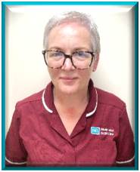
“Thank you for your continued support in keeping our children and young people healthy happy and safe. Together, we can encourage healthy lifestyle choices improving the health and wellbeing of our children and young people.”

If you have any questions about your child’s health, vaccination programmes, or would like advice, please contact the School Nursing Team via the numbers in the link.
Please use the link below:
School Nursing Service - Northern Health and Social Care Trust

Or scan the QR to connect to the NHSCT website:
How to contact us:







Please share your experiences of School Nursing in NHSCT via the link below.
Care Opinion
4

